Arizona is home to a rich and diverse network of tribal courts. Many of our attorneys regularly engage with tribal court systems—not only in Arizona but across the country—handling matters that require access to the case law of those jurisdictions. While vLex Fastcase provides access to tribal cases, finding them on the platform can be challenging. This guide outlines how to find cases from tribal courts across the country to help make your research time more efficient.

**Finding Tribal Court Cases:**

Start from the homepage “Fastcase.vlex.com”. Look for the blue search bar on the lefthand side of the screen. Click the fourth option - “browse” (it will have a small compass icon next to it). This will bring up the first in a series of pop-up menus. First, select “case law.” On the next menu, select “Browse by Court.” Next, select “Tribal Courts” – note that this option will be almost the last option on the menu.

The final pop-up menu will be a list of all tribal courts. Select your desired court and vLex will provide a list of cases from that court. You can run a search term through the cases in that court by entering it into the “Search in Results” white box on the lefthand side of the page.

Please note – vLex Fastcase currently does not allow you to run search terms against the cases of multiple tribal courts. Additionally, if you run a search term against all US courts, it will not include tribal courts. You must select a specific tribal court and then run the term against it. This guide will be updated if vLex updates that feature.

Please see the next page for a screen print walkthrough of these instructions. If you have any questions, please call the Practice 2.0 helpline at 602.340.7332.

**Screen Print Walkthrough of Finding Tribal Court Cases**

From the main screen – click “browse” – “case law” – “browse by court” – “Tribal Courts”.

“Tribal Courts” is near the bottom.  Click on “Tribal Courts” to get a list of the individual courts.

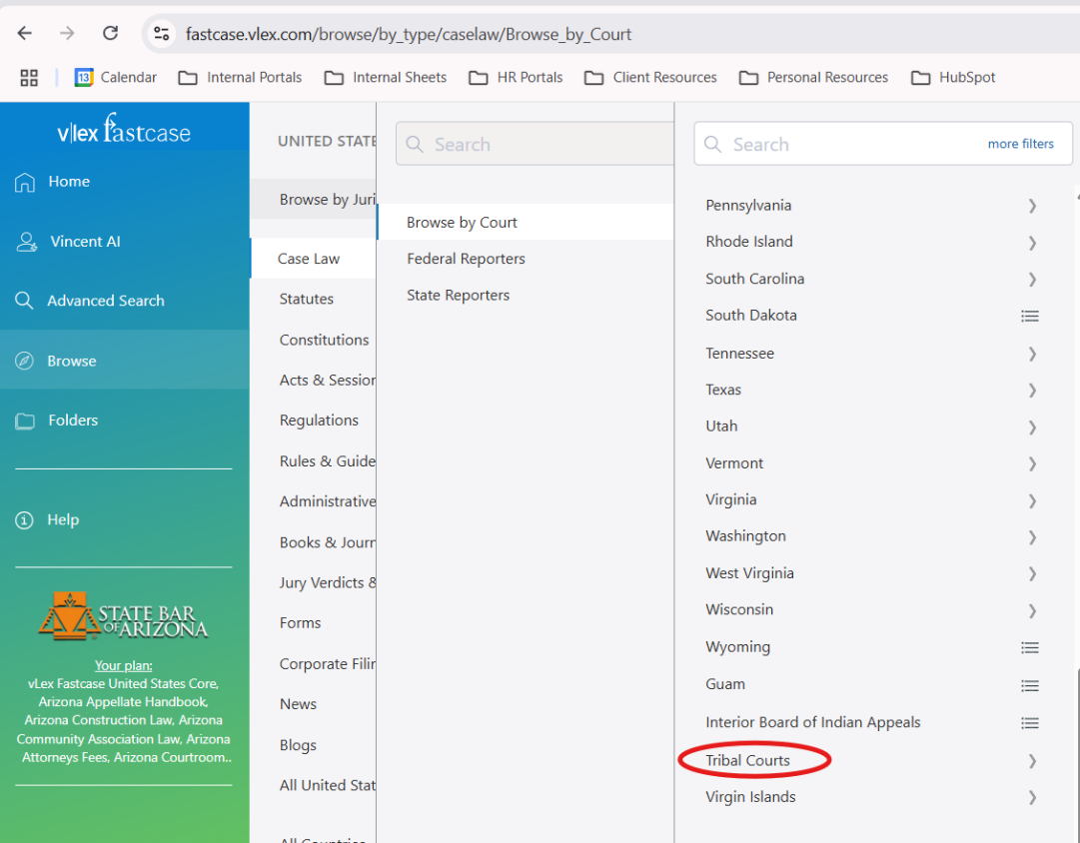

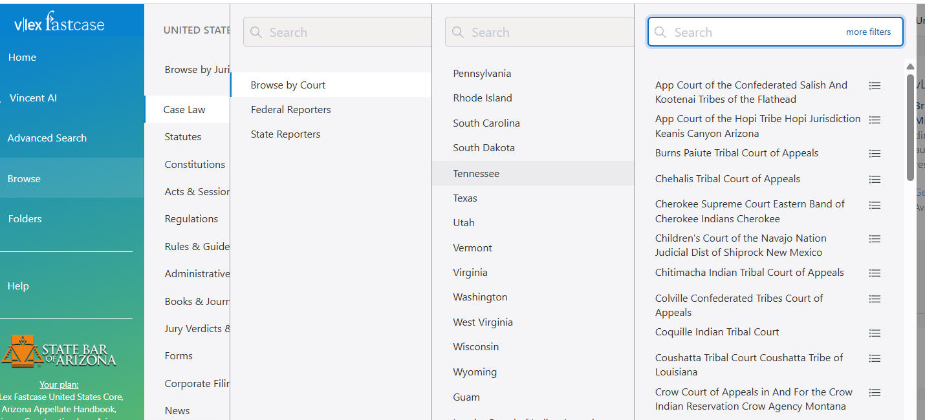

**Searching Cases:**

To search in a particular court – navigate to that court.  Click on the court, and then use the search in results bar on the left to search specific terms.

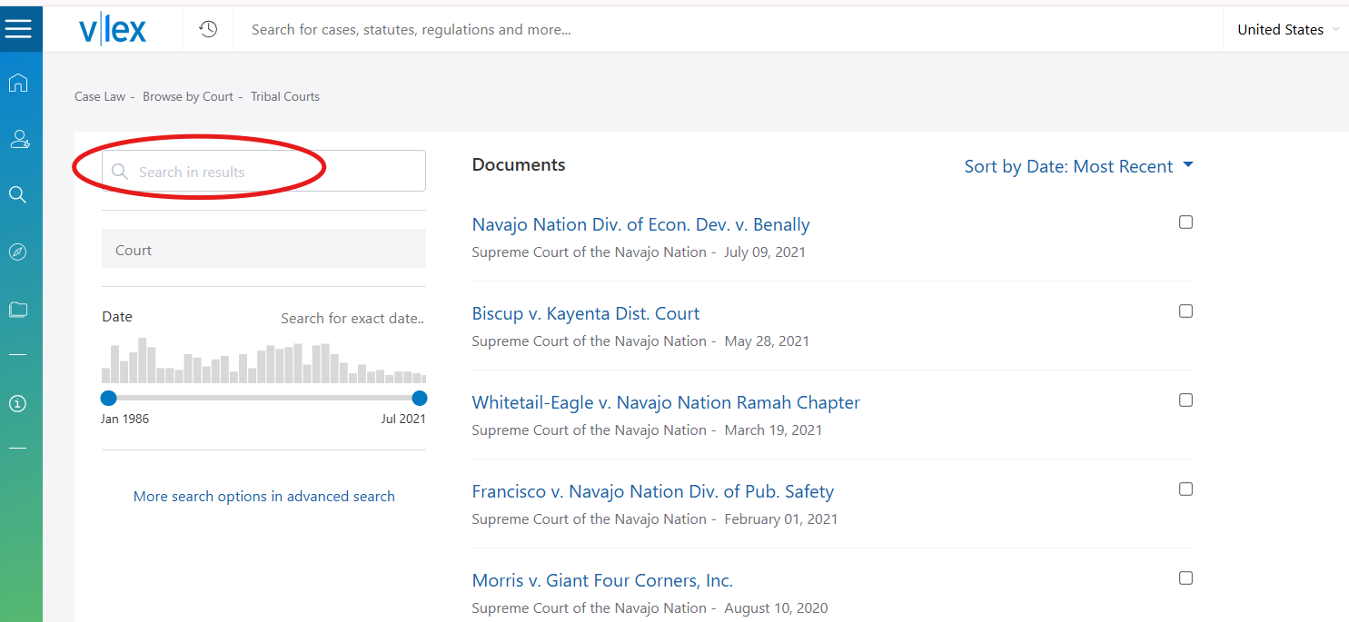

Please note – vLex Fastcase currently does not allow you to run search terms against the cases of multiple tribal courts. Additionally, if you run a search term against all US courts generally, it will not include tribal courts. You must select a specific tribal court and then run the term against it. This guide will be updated if vLex updates that feature.

**If you have any questions, please call the Practice 2.0 helpline at 602.340.7332.**

