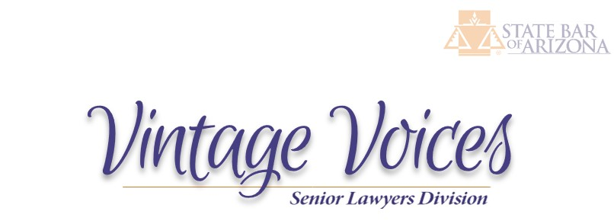

VINTAGE VOICES
October 2026


Be sure to vote on November 3!

President’s Column

Arizona Supreme Court Rule 38(d)(1) governs the approval of Legal Services Organizations, or LSOs. An LSO “. . . is a non-profit legal entity that has as one of its primary purposes the provision of free civil legal assistance to low income individuals.” The rule then explains the filing requirements in order for an LSO to be approved all, of which culminates in an opportunity for the State Bar to comment on the application. Once approved, an LSO must file an annual notice with the Supreme Court providing updated information and various certifications.

As of February 17, 2026, there were twenty-five approved LSOs Arizona. Several of those, such as Community Legal Services and Southern Arizona Legal Aid, are immediately recognizable. Others, perhaps, not so much. A list of approved LSOs can be found at www.azcourts.gov/clerkofcourt/Legal-Services-Organizations.

One LSO you should know more about is Legal Services for Crime Victims in Arizona. Located in Sun City, LSCVA is active in eleven of Arizona’s fifteen counties as it provides free legal services to ensure that Section 2.1, Article 2 of the Arizona Constitution is fulfilled: “A victim of crime has a right to be treated with fairness, respect and dignity . . . .” This is accomplished by providing free legal representation to crime victims as they navigate the criminal justice process and by providing social services in the aftermath of crime when many victims feel lost and alone with few support systems. History teaches that without this kind of support, and the strong directive in the Arizona Constitution, victims have alternately been treated unfairly, overlooked, excluded or considered to be merely another piece of evidence in a criminal trial.

The specific programs of LSCVA are the following:
• Victim Rights Enforcement Program: Provides free legal representation in criminal cases to victims of crime with priority to domestic and sexual violence.
• Protective Order Program: Provides free legal representation and support to address the immediate and ongoing safety needs of crime victims.
• Domestic Violence Legal Document Preparer Program: Provides general legal information, completes and files legal documents, and assists with preparation for hearings.
• Court Watch Program: Utilizes civic engagement to monitor issues relevant to victim’s rights in court systems.
More information about LSCVA and how you can help is available at www.lscva.org.

Charles Thomson President, SLD

Update on Rule 38

Our Division Access to Justice Task Force was successful in convincing the State Bar’s Board of Governor’s Rules Review Committee that Supreme Court Rule 38(d) needed amending. Chuck Thomson, President, Mary Helen Maynard, Past President, and Marshall Lehman, Executive Council Member, appeared before the Committee on October 2, 2026. The Committee approved our Division’s recommended changes to Rule 38(d), with only three minor revisions, to make it easier for our Inactive and Retired members, who are not permitted to practice law other than certification through Rule 38, to provide pro bono services to the Court approved Legal Services Organizations (LSOs) in Arizona. The first revision to our proposal was to provide a footnote to our addition of criminal pro bono work to Rule 38(d). The reason is that many LSOs receive funding through the Legal Services Corporation which prohibits them from providing pro bono criminal representation except for minor offenses in Indian tribal courts. Our proposed footnote states that our Division is aware of this restriction. Our addition of criminal pro bono does not require the LSOs to provide it or to secure federal or state funding. In other words, if an LSO does not receive federal or state funding and may provide that criminal pro bono service, we want our retired and inactive members to be able to be involved. The other two changes are to add “and supervision” after the word “auspices” in the Rule and to change “licensed” to practice law to “admitted” to practice law.

The next stop is the Board of Governors at its December 11 meeting. If approved, the State Bar Counsel will take our Petition to amend Rule 38 to the Supreme Court. The Court is anticipated to act upon it next Summer.

Thanks to our Task Force members: Maureen Kane, Dianne Post, Scott DeWald, Marshall Lehman, Mary Helen Maynard, David Vasquez, Chuck Thomson (our Chair), and your humble servant. Stay tuned for more updates here at the Vintage Voices as our work has just begun.

ABA Senior Lawyers

Are you a member of the ABA? If so, please join the Senior Lawyers Division – it’s free. Below are the web link; a description of the ABA SLD; and an example of what the Division is doing this month.

https://www.americanbar.org/groups/senior_lawyers/

Who We Are
The SLD has nearly 50,000 of the most senior and accomplished members of the ABA. Any ABA member can join for free. Those age 60 and over or practicing 35 years or more are automatically enrolled. The Division provides member benefits such as magazines, e-newsletters, and webinars.

Stories

Editor’s Note
We welcome articles, comments, and stories from our Members. Please send to me at denise@azlaborlaw.com

Lesson Learned
By Dianne Post

We were in a divorce trial and both sides had counsel.

At one point, the judge stopped the case and ordered us into his office. That's when they did that.

We sat.

He started on a rampage about how badly we were doing, not knowing how to question or cross or introduce evidence or object etc. And not following the local rules. I didn't even know there were local rules.

Then he said, "How long have you been practicing Ms. Post?"

I replied, “4 months.”

He said, “Well you are forgiven.”

He turned to the other lawyer, "How long have you been practicing Mr. [I forgot his name]?"

He replied, “10 years.” The judge said, “You are not forgiven.

So, get yourselves together, come back another time [he gave us a date] and do it right.”

Well, you can bet I found those local rules, studied them, revised what I was doing and made sure he would have nothing to yell at me for next time.

The next week we were back and continued the trial. Mr. X had done nothing and continued in exactly the same way he had before. I trounced him and learned a good lesson.

Popular Culture

Editor’s Note
We welcome movie and TV reviews and (clean) jokes from our Members. Please send to me at denise@azlaborlaw.com

Movies: There are too many horror flicks – but it’s the season. Avengers Endgame, an “origin” movie, is doing really well at the box office - probably to fill in all the gaps for those who go to the newest Marvel Avengers movie later this year.

Television: Netflix brings back another season of The Diplomat. The Final Problem, a Spanish murder mystery, is an interesting four-part series to binge on Netflix. The Fall schedule is out on the major over-the-air channels. I can’t wait for Slow Horses on Apple TV, which is the funniest show on TV. I really like Signora Volpe on Acorn. Did you hear that Ghosts will be coming back on CBS? Just in time for Halloween.

Funnies:

An engineer was sent to Hades. She complained to Satan, who reminded the engineer of her evil ways on Earth.
Two months later, the Almighty came to meet Satan at their quarterly meeting at the boundary between Heaven and Hell. The Almighty remarked that the air seemed cooler than usual; the roads were clear; and the swimming pool was full of water rather than fire. Satan bragged that he had an engineer who fixed the air conditioning, roads, and swimming pool.
The Almighty said, “That simply will not do. I’ll sue you to get that engineer.”
Satan replied, “Where are you going to get a lawyer?”


Until next time,
Denise (married to an engineer )

The SLD is currently pursuing a Petition to Amend Rule 38(d)(1) to include free criminal assistance as well.

